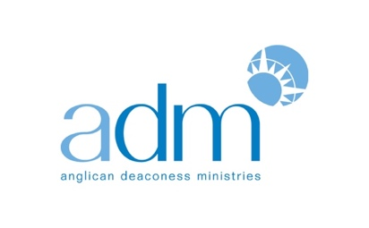

ADM to award over $50,000 in funding to women

Applications are now open for this year’s Annual Funding Event

Sydney, 1 June 2018

Anglican Deaconess Ministries (ADM) has today opened applications for its Annual Funding Event.

Now in its third year, this event provides an opportunity for entrepreneurial Christian women to bring their ideas and initiatives before a panel and pitch for funding.

In 2018, the Annual Funding Event will be held on Wednesday, 19 September. Funds will be awarded in three categories, based on ADM’s core program areas: ‘Form’ (theological formation), ‘Engage’ (public engagement), and ‘Do’ (mercy and justice ministries, or mental health and pastoral care). A fourth category, ‘Ideas’, will allow women to receive feedback on their ideas for an organisation or initiative that has not yet been created.

The first-place winner across the ‘Form’, ‘Engage’ and ‘Do’ categories will receive $25,000, while prizes of $12,500 will be awarded to winners in the other two categories. Every woman who is selected to pitch on the day will receive $1,000 towards their initiative.

In addition to cash prizes, category winners at the Annual Funding Event will form part of the 2019 cohort of The Hub at ADM. In 2019, The Hub will be an invite-only mentoring program designed to enable entrepreneurial Christian women to take their initiatives to the next level. Across the year, the Hub cohort will meet for face-to-face mentoring sessions with exceptional lead coaches who will provide personally-tailored professional development for each woman. Hub participants will also be matched with a mentor with whom they will meet monthly over the phone.

Projects led by women that have received funding at previous Annual Funding Events include Common Grace’s anti-domestic violence initiative ‘Safer’, Hailey McQueen’s stage production of C.S. Lewis’s The Screwtape Letters and ‘Jesus Club’, a Bible-based church program for adults with intellectual disabilities.

ADM’s CEO Dr Kate Harrison Brennan says, “It is such a privilege to showcase the ideas of Christian women and to support them in using their God-given gifts for the good of the world and the Church. We have been amazed by the innovative ideas of Christian women over the past two years of the Annual Funding Event. I look forward to seeing another crop of Christian women being platformed at this year’s event, and to seeing them flourish in Kingdom work as they develop their initiatives throughout 2019.”

To find out more about ADM’s Annual Funding Event, including how to apply to pitch at the event, go to: deaconessministries.org.au/annualfundingevent/.

Media Contact:

Rebecca Abbott, Director of Communications
Anglican Deaconess Ministries

rebecca@deaconessministries.org.au
Mob: 0403 735 990

